Use Case – Document

Module Name: Submitting customer details

Use Case Name: Getting customer details

**ID: 202**

**Name: Submitting customer details**

**Title:**

**Description:**

Once the agent is approved, he/she will get access to submit customer details in system.

**Use Case Diagram:**

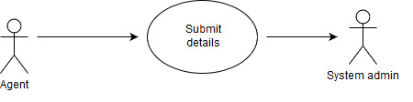

**Pre-Conditions:**

1. Customer details should be available.
2. Customer’s request for the policy.

**Post-Conditions:**

If the use case is successful

1. The details for policy and customer are available.
2. Agent should have access to submit customer details.

**Primary Flow:**

1. After approval of agent by admin.
2. Agent will be able to login in application
3. Agent will get an access to submit details.

**Exception Flow:**

1. Agent should have at least one customer to submit the details.
2. Each customer belonging to a particular agent should have at least one policy .

**Data:**

|  |  |  |
| --- | --- | --- |
| Sr. No. | Data | Datatype |
| 1 | NAME | VARCHAR2(20) |
| 2 | DATE OF BIRTH | DATE |
| 3 | GENDER | VARCHAR2(7) |
| 4 | OCCUPATION | VARCHAR2(20) |
| 5 | ANNUAL_INCOME | VARCHAR2(20) |
| 6 | NATIONALITY | VARCHAR2(10) |
| 7 | PAN_NO | VARCHAR2(20) |
| 8 | EMAIL_ID | VARCHAR2(20) |
| 9 | CONTACT_NO | NUMBER(20) |
| 10 | PASSWORD | VARCHAR2(10) |
| 11 | AGENT_ID | NUMBER(10) |

**Screen Shots:**

